NAME: **Sristi Sengupta**

DEPARTMENT: **B.Tech(ECE)**

COLLEGE: **Netaji Subhash Engineering College**

STUDENT ID:**AF0453862**

**1)**

create database sample;

use sample;

-- Create the Customer table

CREATE TABLE Customer (

customer_id INT PRIMARY KEY,

first_name VARCHAR(20),

last_name VARCHAR(30)

);

-- Insert sample data into the Customer table

INSERT INTO Customer (customer_id, first_name, last_name)

VALUES

(1, 'John', 'Cartson'),

(2, 'Jane', 'Smith'),

(3, 'Michael', 'Jacksn'),

(4, 'Amelia', 'Williams'),

(5, 'Adya', 'Sharma');

-- Create the Orders table

CREATE TABLE Orders (

order_id INT PRIMARY KEY,

order_date DATE,

total_amount INT,

customer_id INT,

FOREIGN KEY (customer_id) REFERENCES Customer(customer_id)

);

-- Insert sample data into the Orders table

INSERT INTO Orders (order_id, order_date, total_amount, customer_id)

VALUES

(101, '2024-10-01', 150, 1),

(102, '2024-10-03', 250, 1),

(103, '2024-10-05', 120, 2),

(104, '2024-10-07', 300, 3),

(105, '2024-10-09', 180, 4),

(106, '2024-10-11', 220, 5),

(107, '2024-10-12', 110, 2),

(108, '2024-10-15', 280, 3);

SHOW TABLES;

SELECT * FROM Customer;

SELECT * FROM Orders;

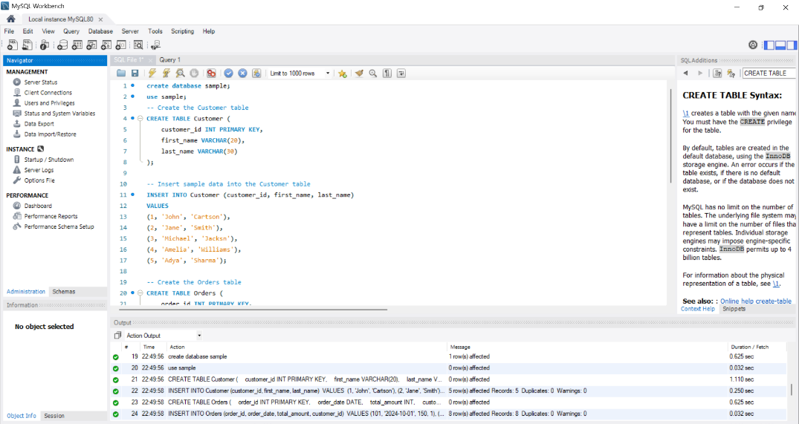

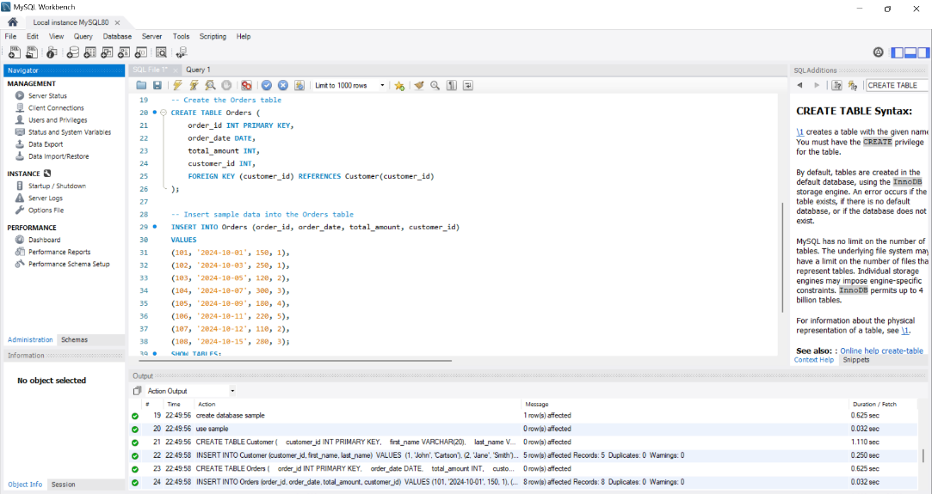

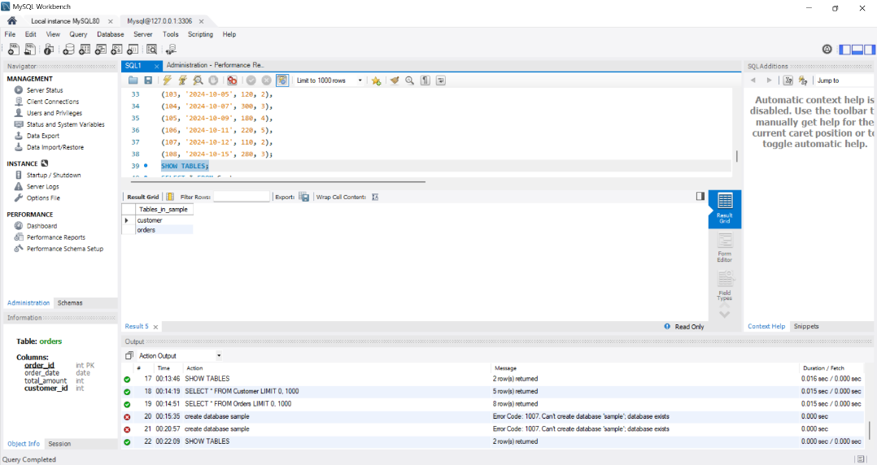

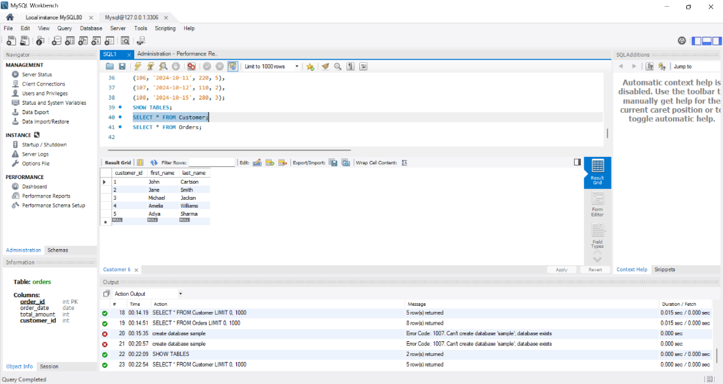

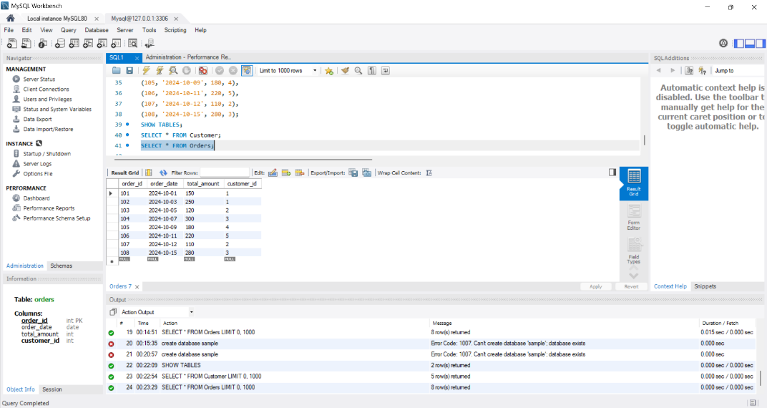

**2)**

CREATE DATABASE TestDB;

USE TestDB;

-- Create Department table

CREATE TABLE Department (

department_id INT PRIMARY KEY,

department_name VARCHAR(30)

);

-- Insert data into Department table

INSERT INTO Department (department_id, department_name) VALUES (1, 'HR');

INSERT INTO Department (department_id, department_name) VALUES (2, 'Finance');

INSERT INTO Department (department_id, department_name) VALUES (3, 'IT');

INSERT INTO Department (department_id, department_name) VALUES (4, 'Marketing');

-- Create Employees table

CREATE TABLE Employees (

employee_id INT PRIMARY KEY,

first_name VARCHAR(30),

last_name VARCHAR(30),

department_id INT,

FOREIGN KEY (department_id) REFERENCES Department(department_id)

);

-- Insert data into Employees table

INSERT INTO Employees (employee_id, first_name, last_name, department_id) VALUES (1, 'Eshan', 'Raichand', 1);

INSERT INTO Employees (employee_id, first_name, last_name, department_id) VALUES (2, 'Brinti', 'Kumari', 2);

INSERT INTO Employees (employee_id, first_name, last_name, department_id) VALUES (3, 'Sherley', 'D.Rozario', 3);

-- Adding an employee without a department for testing LEFT JOIN

INSERT INTO Employees (employee_id, first_name, last_name, department_id) VALUES (4, 'Alizeh', 'Zubair', NULL); -- Alizeh has not been assigned any department

-- Left Join Query

SELECT Department.department_name, Employees.first_name, Employees.last_name

FROM Department

LEFT JOIN Employees ON Department.department_id = Employees.department_id;

SHOW TABLES;

SELECT * FROM Department;

SELECT * FROM Employees;

